

Save a copy of this document somewhere you can access.

This is ***your*** learning journal. Make sure that you keep it updated as you progress through the Project. Your teacher will let you know when to complete each step. Document both your successes and your failings as they provide the most important learning opportunities!

To get started, please type your name in the following box:

|  |
| --- |
|  |

# Step 1: Define

If instructed by your teacher, please answer the rest of the Define questions.

## Define the situation

After watching the video in the [Define](http://app.createbase.co.nz/project/aimbot/define) step on the platform, answer the questions below.

First, let’s look at what problem we are trying to solve.

1. **List 5 things you can observe from the video.**

**Remember, an observation is what you can see, not what you think is happening!**

|  |
| --- |
|  |

1. **Using your observations from the previous question, come up with 2 inferences about what is happening in the video.**

**Remember, an inference is a short conclusion made based on evidence (observations).**

|  |
| --- |
|  |

1. **Based on your inference made in the previous question, what do you think is the main problem that is being described in the video?**

|  |
| --- |
|  |

Excellent! Now let’s find out why this could be a problem for us and the wider community.

1. **What do you think would happen as a result of this problem?**

**Let’s think about the positive and negative impact of this issue in different areas, such as…**

* **Who would be affected by this the most? Think about the age, jobs or areas they live.**
* **What daily activities could be affected by this? Think about what you do every day.**
* **Think about other things that could be affected by this issue that are not people! Plants, animals and the environment.**

|  |  |  |
| --- | --- | --- |
| **Who would be affected?** | **Positive impact** | **Negative impact** |
|  |  |  |

1. **Now we have thought about what impact this problem might have, let’s think about how this problem was created.**

**What do you think has happened beforehand that caused this to happen? List 3 things**

|  |
| --- |
|  |

# 

# Step 2: Imagine

If instructed by your teacher, answer the following questions in Imagine before returning to the platform. If you are working in a group, discuss all of your answers as a team, but make sure that every member writes a summary in their own learning journal in the box below. Bullet points and incomplete sentences are acceptable.

## Imagine your solution

1. **Let’s think back to the cause of the problem you described in ‘Define’ questions.**

**Think of two ways the negative impacts could be reduced.**

* **This could be something small that you could do by yourself.**
* **This could be something big that an organisation or country could do.**
* **This could be something that uses different areas of knowledge like businesses, chemistry, biology or technology.**

|  |
| --- |
|  |

**Mikaere is a scientist who has been assigned a mission to design a solution! She must use humanoid robots that already exist. These robots have different parts to help with the task.**

* **Mounted laser**
* **Motors in the arm**
* **Sensors for detection**

1. **For each of these parts, what kind of action could it allow robots to do?**

|  |  |
| --- | --- |
| **Parts** | **Actions** |
| **Mounted laser** |  |
| **Motors in the arm** |  |
| **Sensors for detection** |  |

1. **Using all of the parts available, describe how this robot could be used to help solve the problem.**

|  |
| --- |
|  |

1. **How could we make sure this robot carries out the action accurately to prevent any mistakes from happening?**

|  |
| --- |
|  |

That's it so far for the learning journal! When you have finished answering these questions, return to the platform and read through the content in the Imagine step to learn about the tools and methods that you will use to solve this problem throughout the remainder of the Project: <https://app.createbase.co.nz/project/aimbot/imagine>.

Once you have read the Imagine content and/or when instructed by your teacher, proceed to the Create step. In the Create step, you will be presented with the subsystems described in Imagine.

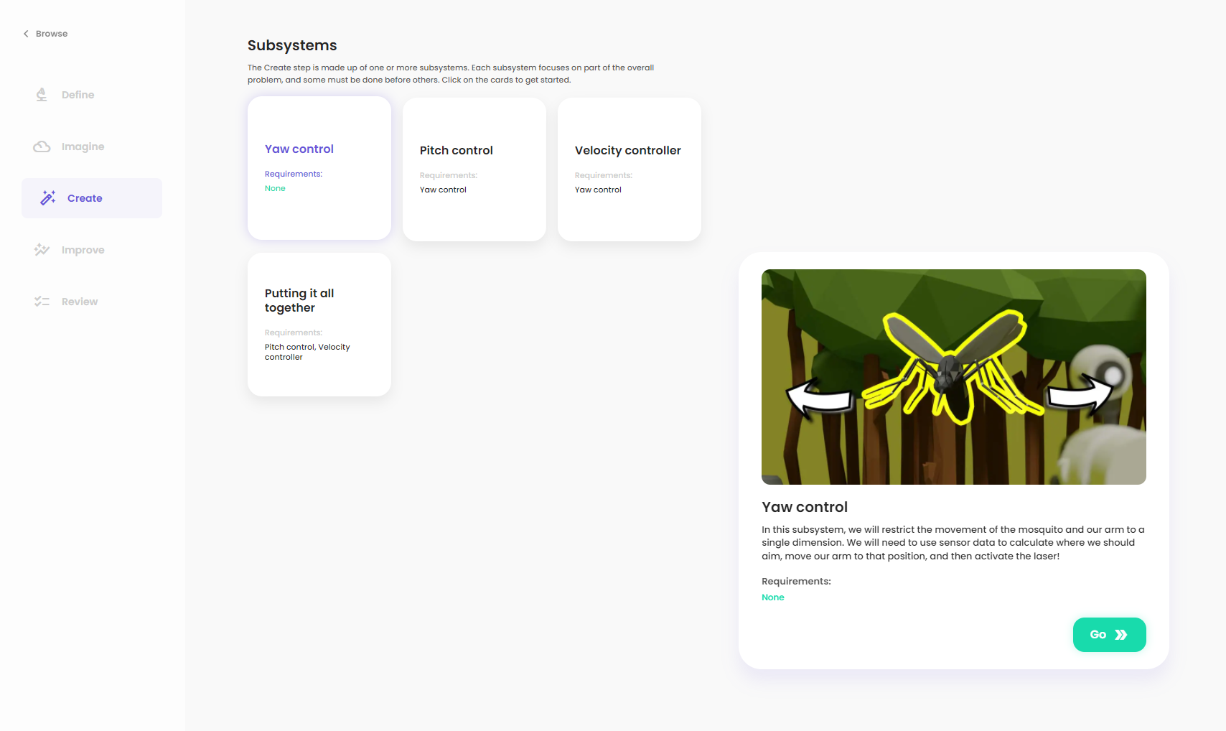

Select the first subsystem, press ”Go”, and then use the contents in the platform to answer the Research, Plan and Code questions in your learning journal below. Rinse and repeat for each subsystem in order until you have successfully completed the Project!

# Step 3: Create

## Subsystem I

### Research

The robot needs to aim at the correct target before activating its laser so that we don’t fire at non-mosquito targets! To be able to aim left and right, we need to change the yaw of the robot. Navigate to the platform and read the [Research](http://app.createbase.co.nz/project/aimbot/create/Yaw%20control/research) information for the first subsystem. Then, answer the following questions to learn more about axis and trigonometry...

1. **What is an axis? Describe axis without using the word ‘rotation’.**

|  |
| --- |
|  |

1. **Why would identifying the axis be important when we give instructions?**

|  |
| --- |
|  |

**Please read through the trigonometry information sheets and answer the following questions.**

1.5m

3m

**ϴ**

1. **To find the missing angle for the triangle above, what trigonometry function would you use?**

|  |
| --- |
|  |

1. **Here is the formula to help find the missing angle. Using the values from the triangle above and the answer from the previous question, fill out the missing values in the formula.**

**Don’t forget the units of the distance!**

|  |
| --- |
| ϴ = ⁻¹ ( ) |

1. **Using your physical calculator or** [**this online calculator**](https://www.calculator.net/)**, find the value of the missing angle. Round it up to the nearest 2dp. Don’t be alarmed if your answer is less than 1. It’s because the answer is in radian. We will convert this to degrees in the next question.**

|  |
| --- |
| ϴ = |

1. **Convert your answer in question 5 from radians to degrees by following the instructions below. Read the** [**information sheet**](https://www.expii.com/t/what-are-degrees-and-radians-10596#:~:text=Degrees%20and%20Radians%3F-,Degrees%20and%20radians%20are%20ways%20of%20measuring%20angles.,is%20equal%20to%202%CF%80%20radians.) **to find out more about radians and degrees.** 
   1. Multiply radian by 180
   2. Divide the answer by pi (ℼ)

|  |
| --- |
|  |

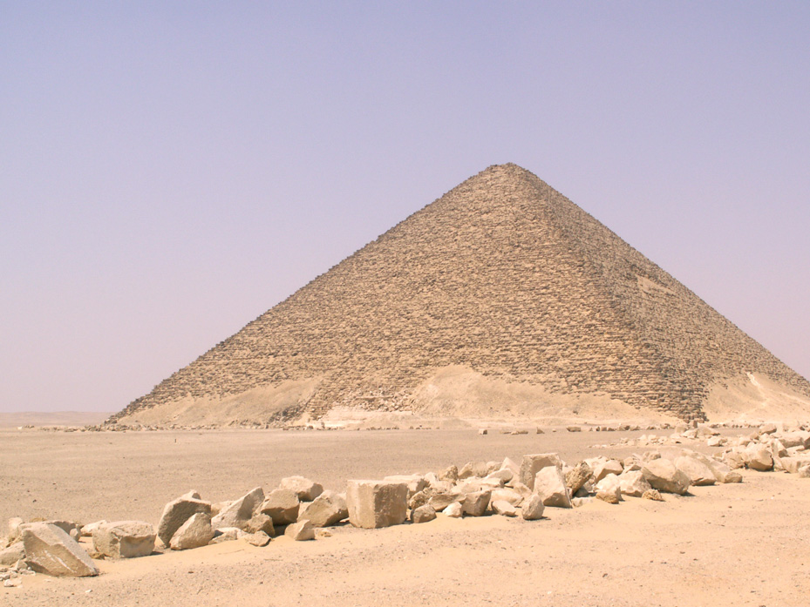

**30m**

**18m**

**ϴ**

1. **An architect in ancient Egypt has been tasked to create a pyramid!**

**The architect is wondering how steep the pyramid has to be. Use trigonometry and** [**this online calculator**](https://www.calculator.net/) **to find the missing angle. Make sure to convert radians to degrees after.**

|  |
| --- |
| ϴ = ⁻¹ ( )  ϴ =  The angle in degrees is = |

### 

### Plan

In this step, our aim is to understand what information is required to calculate the missing angles. We will then use trigonometry to calculate the unknown angle. To do this, let’s attempt to try and answer the following questions.

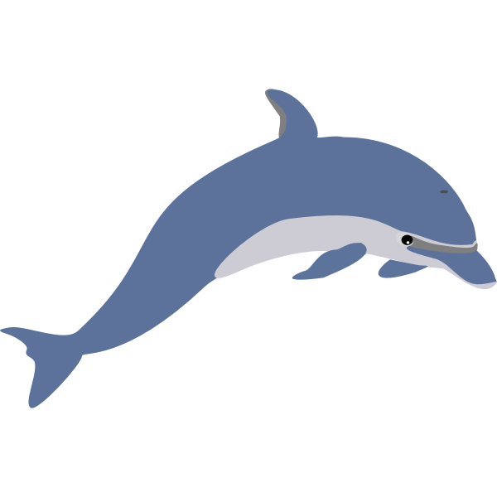

A

B

ϴ



Manu thinks she saw a dolphin as she was paddling in her kayak. She wants to rotate towards the direction to paddle closer to it. With her GPS radar device, let’s use trigonometry to help calculate the angle.

1. On her radar device, she can see her current position and there is a blue dot that shows up as what could be a dolphin! We have practiced finding missing angles in previous questions! Let’s put it to use. **What shape do we draw between Manu and the blue dot to help calculate the angle?**

|  |
| --- |
|  |

1. The GPS device has a touch screen. First, we need Manu to touch the screen to input the position of the place she wants to head towards.

**Where do we want to head towards?**

|  |
| --- |
|  |

1. Excellent. Now that we have the position of the place we want to get to, the GPS has calculated the distances A and B. However, the screen is showing these values:

Opposite: 10 m

Adjacent: 12 m

**Match up the values with the correct sides.**

|  |
| --- |
| A:  B: |

1. **With your answers above, use trigonometry and** [**this online calculator**](https://www.calculator.net/) **to find the missing angle.**

|  |
| --- |
| ϴ = ⁻¹ ( )  ϴ =  The angle in radians = |

1. **The missing angle at the moment is in radians. Let’s convert this to degrees.**

|  |
| --- |
|  |

1. Manu now has the target angle she must rotate to in degrees. **If Manu wants to rotate her kayak this many degrees as fast as possible without overshooting, what speed should she turn at in degrees per second? How many seconds would Manu need to travel at this speed for?** Assume that Manu will turn at a constant speed and that the amount of time she spends turning must be a non-zero multiple of 1 second.

|  |
| --- |
|  |



0°



1. We have the speed, now we need to set the direction. To find the direction, we must compare our current angle to the target angle. On the diagram, Manu is facing north. This means her current angle is 0. This means Manu can set the direction to negative and positive values of the angle calculated in question 5. **What direction would she turn if she set the direction to negative and positive? Which one should she choose?**

|  |
| --- |
| -angle would turn the kayak towards: Left/Right  +angle would turn the kayak towards: Left/Right  This means Manu must turn at a speed of +/- ______ degrees per second to reach the target angle from her current position facing north. |

1. Manu has now redirected the kayak to the angle from question 5 at the speed from question 7. But she might have some trouble if she left the speed at the same value. **How should she adjust the speed for the different scenarios below?**
2. The dolphin seems to be moving faster than Manu is currently rotating her kayak. The kayak is moving too slow to adjust to the constant change in the dolphin’s position. How should she adjust her speed?

|  |
| --- |
|  |

1. The kayak speed seems to be faster than the dolphin! She’s risking going past the dolphin’s position at the current speed. What can she do to prevent the kayak from going past it?

|  |
| --- |
|  |

To navigate accurately, it’s important to balance the two factors that we identified above. We need to get to the destination as fast as possible but not too fast! We are going to find out how to balance this more efficiently.

The following graph showcases the relationship between our optimal speed and the remaining angle, assuming that we are travelling at a constant speed.

Difference between target angle and current angle

Optimum Speed

1. **Have a look at the graph above. What is happening to optimum speed when the distance between the target angle and the current angle increases?**

Optimum: the most favourable thing for a situation.

|  |
| --- |
|  |

1. Think about what our target angle and current angle are.

**When would the difference between the target angle and the current angle be largest for Manu?**

|  |
| --- |
|  |

1. **When would the difference between the target angle and the current angle be lowest for Manu?**

|  |
| --- |
|  |

Let’s now suppose that Manu will rotate at a constant speed but can change it once at the start of each one-second interval. For example, if Manu turns for 2 seconds, she will be able to change her speed twice, once at 0 seconds and again at 1 second. She will continue travelling at the speed she sets at 0 seconds between the 0-1 second interval and will continue travelling at the speed she sets at 1 second between the 1-2 second interval.

1. **Observe the graph in question 8 carefully and fill out the table below to find out how we can use this information to change our speed in different situations.**

|  |  |  |
| --- | --- | --- |
| **Situation** | **Manu’s speed should be (faster, medium, slower, stop):** | **What observation have you made from the graph to support your answer?** |
| When Manu has not yet turned her kayak, and has 4 seconds remaining. |  |  |
| When Manu’s kayak has rotated almost halfway towards the dolphin, and she still has 3 seconds remaining. |  |  |
| When the kayak’s angle is almost aligned to the dolphin’s position, and she still has 2 seconds remaining. |  |  |
| When the kayak’s angle is perfectly aligned to the dolphin’s position, but she still has 1 second remaining. |  |  |

1. Just like how Manu can only change her rotational speed once every second, our robot will also only update its speed once each interval. The length of this interval is much shorter than 1 second, however. Each time your code is run, it will update the robot’s speed (if you add the appropriate block) and then automatically loop to the start once you have added the final block.

Hopefully you have realised that we want our robot to turn quickly when its aim is far away from the mosquito but slow down as it gets close to prevent overshooting its target.

**Describe how you plan on dynamically adjusting the speed of the robot’s yaw rotation to minimise the time taken to reach the target without overshooting. Make sure that you describe the information and/or calculations you are using to determine the correct speed.**

|  |
| --- |
|  |

## 

### Code

You can now return to the platform and create your code answer as part of the Code step. Make sure that you refer back to the Research and Plan content in your learning journal or the platform whenever you get stuck!

When you have finished with Code, add a screenshot of your final solution below showing the success screen as well as either the Flow or text code. Then, write a brief explanation of how it works, including any problems that you encountered along the way and how you overcame them:

|  |
| --- |
|  |

You can now move on to the next subsystem.

# 

## Subsystem II

### Research

In the previous subsystem, we could have used an IF statement to only activate our laser when the difference between our target and current yaw angles was less than some value.

In this subsystem, we now also need to check the difference in target and current pitch angles before we activate the laser. We could do this using two sequential if statements, or, we could use a logical AND statement. Return to the platform and read the Research content to learn about logical blocks:

<http://app.createbase.co.nz/project/aimbot/create/Pitch%20control/research>

1. **Explain how you could use two IF blocks to only activate the laser when both the pitch and yaw angles are within 1 degree of the target.**

|  |
| --- |
|  |

1. **Explain how you could use one logical block and one IF block to only activate the laser when both the pitch and yaw angles are within 1 degree of the target. Make sure that you mention which logical block you would use.**

|  |
| --- |
|  |

### Plan

In this step, our aim is to duplicate our code for controlling the yaw axis so that we can also control the pitch axis. To do this, let’s attempt to try and answer the following questions.

1. **To solve this sub-problem, you are going to need to change both your robot’s yaw angle and pitch angle. Which one are you going to move into position first? Does the order matter? Can you move them at the same time? Describe what you are going to try first.**

|  |
| --- |
|  |

1. **Are there any advantages to using logical blocks over IF blocks and vice versa in our situation? If so, list them below.**

|  |
| --- |
|  |

1. **Are you going to try and use logical blocks, IF blocks, or both when you code your solution? Explain your reasoning.**

|  |
| --- |
|  |

### 

### Code

You can now return to the platform and create your code answer as part of the Code step. Make sure that you refer back to the Research and Plan content in your learning journal or the platform whenever you get stuck!

When you have finished with Code, add a screenshot of your final solution below showing the success screen as well as either the Flow or text code. Then, write a brief explanation of how it works, including any problems that you encountered along the way and how you overcame them:

|  |
| --- |
|  |

You can now move on to the next subsystem.

# 

## Subsystem III

### Research

In the previous subsystems, we were able to accelerate our arm as fast as possible to reach the target location. The only thing that we had to worry about was moving so fast that we overshot our target.

In this subsystem, we are going to make our simulation more realistic by incorporating a damage model for our robot. If we accelerate too quickly, our robot will break from the generated internal forces.

Read the Intro to Forces research document on the platform for subsystem 3 to learn more about forces and then answer the following questions.

1. **Explain how we can prevent our robot from breaking in this new simulation.**

|  |
| --- |
|  |

Read the Intro to Controllers document on the platform for subsystem 3 to learn a little about what a controller is and how this is relevant to our problem.

1. **Explain what the word proportional means using any resources that you have access to.**

|  |
| --- |
|  |

1. **A proportional controller uses feedback from the current state of the system in order to control the next state of the system. Describe what the “current state” and “next state” refer to in our system. Hint: think about what values are updated each time that our code runs.**

|  |
| --- |
|  |

Read the Finer Velocity Control document on the platform for subsystem 3 to gain some insight into how we can build a smart solution to this sub-problem.

1. **Explain what a variable is and why they are important for implementing a proportional controller. Hint: how do we remember what the previous state was?**

|  |
| --- |
|  |

1. **If our current yaw speed is 30 degrees per second and our target yaw speed is 200 degrees per second, what should we set our new yaw speed to? Explain why you chose this value.**

|  |
| --- |
|  |

1. **If our current yaw speed is 0 degrees per second and our target yaw speed is 200 degrees per second, what should we set our new yaw speed to? Explain why you chose this value.**

|  |
| --- |
|  |

1. **If our current yaw speed is 30 degrees per second and our target yaw speed is -90 degrees per second, what should we set our new yaw speed to? Explain why you chose this value.**

|  |
| --- |
|  |

1. **If our current yaw speed is 90 degrees per second and our target yaw speed is -180 degrees per second, what should we set our new yaw speed to? Explain why you chose this value.**

|  |
| --- |
|  |

### 

### Plan

In this step, our aim is to upgrade our code from subsystem 1 to make sure that it doesn’t break. To do this, let’s attempt to try and answer the following questions.



A

B

ϴ



Manu thinks that she has seen another dolphin as she was paddling in her kayak. She wants to rotate towards the direction to paddle closer to it. This time however, her kayak is not very stable. She is worried that if she turns too rapidly, her kayak might tip over. With her GPS radar device, let’s use trigonometry to help calculate the angle.

1. Manu’s GPS has calculated the distances A and B. However, the screen is showing these values:

Opposite: 7 m

Adjacent: 10 m

**Match up the values with the correct sides.**

|  |
| --- |
| A:  B: |

1. **With your answers above, use trigonometry and** [**this online calculator**](https://www.calculator.net/) **to find the missing angle.**

|  |
| --- |
| ϴ = ⁻¹ ( )  ϴ =  The angle in radians = |

1. **The missing angle at the moment is in radians. Let’s convert this to degrees.**

|  |
| --- |
|  |

1. **If Manu wants to rotate her kayak to face the dolphin as fast as possible without overshooting, what direction and speed should she turn at in degrees per second? How many seconds would Manu need to travel at this speed for?** Assume that Manu will turn at a constant speed and that the seconds she spends turning must be a multiple of 1.Remember that a negative speed corresponds to a rotation to the left and a positive speed corresponds to a rotation to the right when facing north.

|  |
| --- |
|  |

1. Suppose that Manu wants to turn 145 degrees to the right. She can change her current speed at the start of every one-second interval but does not want to change it by more than 15 degrees per second at any given time to avoid tipping over. She also doesn’t want to overshoot her target. Given these conditions, the following table showcases how she could adjust her speed over time to reach the target angle.

|  |  |  |  |  |
| --- | --- | --- | --- | --- |
| **Time interval (s)** | **Old speed (°/s)** | **Speed change (°/s)** | **New speed (°/s)** | **Angle at end of interval (°)** |
| 0-1 | 0 | 15 | 15 | 15 |
| 1-2 | 15 | 15 | 30 | 45 |
| 2-3 | 30 | 15 | 45 | 90 |
| 3-4 | 45 | -15 | 30 | 120 |
| 4-5 | 30 | -15 | 15 | 135 |
| 5-6 | 15 | -5 | 10 | 145 |
| 6-7 | 10 | -10 | 0 | 145 |

Manu is worried that if she changes her speed by more than 10 degrees per second at any instant that her kayak might tip over. Let's assume that Manu can now change her rotation speed at the start of each one-second interval. **If Manu wants to rotate her kayak to face the dolphin as fast as possible without overshooting or tipping over, how many 1 second intervals should Manu take to turn and how should Manu change her speed at the start of each interval? Fill out the table below to show your answer.**

|  |  |  |  |  |
| --- | --- | --- | --- | --- |
| **Time interval (s)** | **Old speed (°/s)** | **Speed change (°/s)** | **New speed (°/s)** | **Angle at end of interval (°)** |
|  |  |  |  |  |
|  |  |  |  |  |
|  |  |  |  |  |
|  |  |  |  |  |
|  |  |  |  |  |
|  |  |  |  |  |

### Code

You can now return to the platform and create your code answer as part of the Code step. Make sure that you refer back to the Research and Plan content in your learning journal or the platform whenever you get stuck!

When you have finished with Code, add a screenshot of your final solution below showing the success screen as well as either the Flow or text code. Then, write a brief explanation of how it works, including any problems that you encountered along the way and how you overcame them:

|  |
| --- |
|  |

You can now move on to the next subsystem.

# 

## Subsystem IV

### Research

In this final subsystem, we will be putting together everything that we have learnt so far to solve the complete problem, so there is nothing new to research.

### Plan

In this step, our aim is to duplicate our code for controlling the yaw axis with velocity control so that we can also control the pitch axis with velocity control. Because you will be replicating a lot of your code from the previous subsystems, we recommend referring back to your past Code steps. You will be extending your answer to subsystem 3 in subsystem 4 just like how you extended your answer to subsystem 1 in subsystem 2. Remind yourself how subsystems 2 and 3 worked and think about how you are going to approach combining them before you move on to Code as there is going to be a lot of code to write.

Once you have a plan in mind for how you want to approach writing your code answer, then proceed to the final Code step.

### Code

You can now return to the platform and create your code answer as part of the Code step. Make sure that you refer back to the Research and Plan content in your learning journal or the platform whenever you get stuck!

When you have finished with Code, add a screenshot of your final solution below showing the success screen as well as either the Flow or text code. Then, write a brief explanation of how it works, including any problems that you encountered along the way and how you overcame them:

|  |
| --- |
|  |

That's it! You now (hopefully) have a working solution.

# 

# Step 4: Improve

Add a screenshot of your final Improve solution below and a brief explanation of how you managed to get better performance than your solution to subsystem 4. You may also want to provide multiple screenshots throughout your development to highlight how your solution improved over time:

|  |
| --- |
|  |

# 

# Step 5: Review

Congratulations on completing the Project! Please type your answers to the following questions:

1. If you had more time available, how could you potentially improve your solution? If your solution to the Create step didn’t work, try and explain why.

|  |
| --- |
|  |

1. Think about what you achieved during the project. What are you most proud of?

|  |
| --- |
|  |

1. Think about the parts of the project that didn’t go well. List up to **three** of them below. If nothing went bad, think about things that you could have done better.

|  |
| --- |
|  |

1. Choose **one** from question 4. Why do you think it didn’t go well? If you were going to redo this Project, what would you do differently to avoid this negative?

|  |
| --- |
|  |

1. The solution that we built during this Project aimed to destroy as many mosquitos as possible to prevent the spread of disease. This was not the only way to address our problem. In retrospect, do you think that our solution was a good idea? Explain why.

|  |
| --- |
|  |

1. Although mosquitos cause a lot of harm as carriers of disease, they also have an important role in the natural ecosystem. What might be a negative consequence of eradicating all mosquitos?

|  |
| --- |
|  |

1. Do you think that there would have been a better solution to this problem than programming a robot to destroy mosquitoes with a laser? Explain why or why not. If yes, try and provide an alternative solution.

|  |
| --- |
|  |